**Integration Testing**

**Integration Test Case**

**URS01** - The user can register themselves as customers.

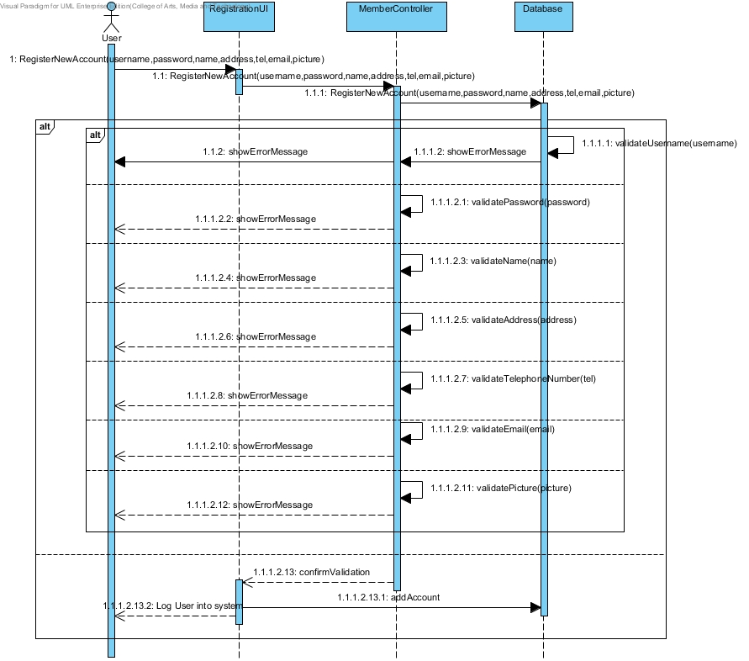

***SD-01: Customer Register***

**ITC-01**

Check the integration between MemberService and MemberDAO by validateUsername() method

|  |  |
| --- | --- |
| **Test Case ID** | ITC-01 |
| **Test Item(s)** | MemberService → MemberDAO |
| **Test Description** | Validate customer account from username that user input |
| **Expect Output** | Return true if username is match with database format. |
| **Actual Output** |  |

**ITC-02**

Check the integration between MemberService and MemberDAO by validatePassword() method

|  |  |
| --- | --- |
| **Test Case ID** | ITC-02 |
| **Test Item(s)** | MemberService → MemberDAO |
| **Test Description** | Validate customer account from password that user input |
| **Expect Output** | Return true if password is match with database format. |
| **Actual Output** |  |

**ITC-03**

Check the integration between MemberService and MemberDAO by validateName() method

|  |  |
| --- | --- |
| **Test Case ID** | ITC-03 |
| **Test Item(s)** | MemberService → MemberDAO |
| **Test Description** | Validate customer account from name that user input |
| **Expect Output** | Return true if name is match with database format. |
| **Actual Output** |  |

**ITC-04**

Check the integration between MemberService and MemberDAO by validateAddress() method

|  |  |
| --- | --- |
| **Test Case ID** | ITC-04 |
| **Test Item(s)** | MemberService → MemberDAO |
| **Test Description** | Validate customer account from address that user input |
| **Expect Output** | Return true if address is match with database format. |
| **Actual Output** |  |

**ITC-05**

Check the integration between MemberService and MemberDAO by validateTelephoneNumber() method

|  |  |
| --- | --- |
| **Test Case ID** | ITC-05 |
| **Test Item(s)** | MemberService → MemberDAO |
| **Test Description** | Validate customer account from telephone number that user input |
| **Expect Output** | Return true if telephone number is match with database format. |
| **Actual Output** |  |

**ITC-06**

Check the integration between MemberService and MemberDAO by validateEmail() method

|  |  |
| --- | --- |
| **Test Case ID** | ITC-06 |
| **Test Item(s)** | MemberService → MemberDAO |
| **Test Description** | Validate customer account from email that user input |
| **Expect Output** | Return true if email is match with database format. |
| **Actual Output** |  |

**ITC-07**

Check the integration between MemberService and MemberDAO by validatePicture() method

|  |  |
| --- | --- |
| **Test Case ID** | ITC-07 |
| **Test Item(s)** | MemberService → MemberDAO |
| **Test Description** | Validate customer account from picture that user input |
| **Expect Output** | Return true if picture is match with database format. |
| **Actual Output** |  |

**Input Data**

|  |  |
| --- | --- |
| **Username** | Great23 |
| **Password** | 12345678GG |
| **Name** | Paradon |
| **Address** | 123 T.SanKlang A.SanKampaeng,  Chiang Mai 50130 |
| **Telephone** | 0881234567 |
| **Email** | Great@cmu.com |
| **Picture** | great180*180.jpg |

**URS02** - The customer can login to the system.

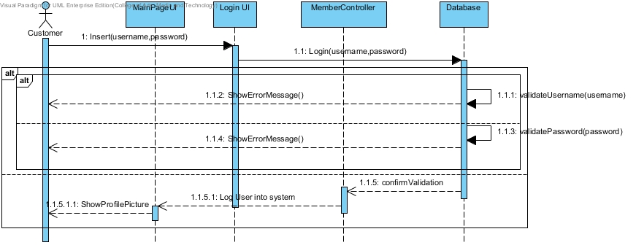

***SD-02: Customer Login***

**ITC-08**

Check the integration between MemberService and MemberDAO by validateUsername() method

|  |  |
| --- | --- |
| **Test Case ID** | ITC-08 |
| **Test Item(s)** | MemberService → MemberDAO |
| **Test Description** | Validate customer account from username that user input |
| **Expect Output** | Return true if username is match with database. |
| **Actual Output** |  |

**ITC-09**

Check the integration between MemberService and MemberDAO by validatePassword() method

|  |  |
| --- | --- |
| **Test Case ID** | ITC-09 |
| **Test Item(s)** | MemberService → MemberDAO |
| **Test Description** | Validate customer account from password that user input |
| **Expect Output** | Return true if password is match with database. |
| **Actual Output** |  |

**Input Data**

|  |  |
| --- | --- |
| **Username:** | Great23 |
| **Password:** | 12345678GG |

**URS03** - The administrator can login to the system.

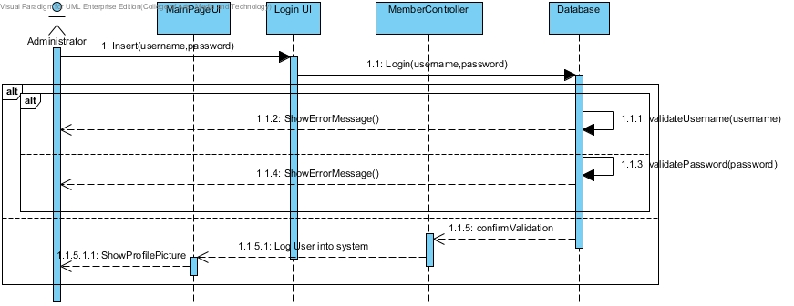

***SD-03: Administrator Login***

**ITC-10**

Check the integration between MemberService and MemberDAO by validateUsername() method

|  |  |
| --- | --- |
| **Test Case ID** | ITC-10 |
| **Test Item(s)** | MemberService → MemberDAO |
| **Test Description** | Validate administrator account from username that administrator input |
| **Expect Output** | Return true if username is match with database. |
| **Actual Output** |  |

**ITC-11**

Check the integration between MemberService and MemberDAO by validatePassword() method

|  |  |
| --- | --- |
| **Test Case ID** | ITC-11 |
| **Test Item(s)** | MemberService → MemberDAO |
| **Test Description** | Validate administrator account from password that administrator input |
| **Expect Output** | Return true if password is match with database. |
| **Actual Output** |  |

**Input Data**

|  |  |
| --- | --- |
| **Username:** | AdminGreat |
| **Password:** | Private23 |

**URS04** - The administrator can add details of the products.

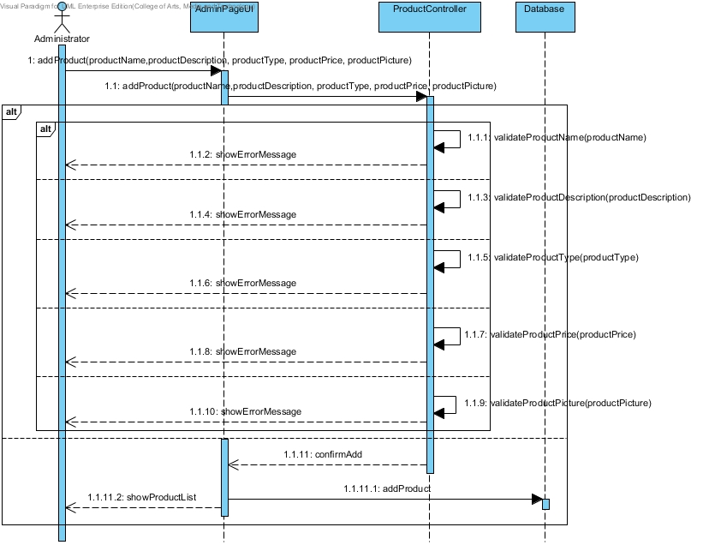

***SD-04: Administrator add details of the products.***

**ITC-12**

Check the integration between ProductService and ProductDAO by validateProductName() method

|  |  |
| --- | --- |
| **Test Case ID** | ITC-12 |
| **Test Item(s)** | ProductService → ProductDAO |
| **Test Description** | Validate product from product name that administrator input |
| **Expect Output** | Return true if product name is match with database format. |
| **Actual Output** |  |

**ITC-13**

Check the integration between ProductService and ProductDAO by validateProductDescription() method

|  |  |
| --- | --- |
| **Test Case ID** | ITC-13 |
| **Test Item(s)** | ProductService → ProductDAO |
| **Test Description** | Validate product from product description that administrator input |
| **Expect Output** | Return true if product description is match with database format. |
| **Actual Output** |  |

**ITC-14**

Check the integration between ProductService and ProductDAO by validateProductType() method

|  |  |
| --- | --- |
| **Test Case ID** | ITC-14 |
| **Test Item(s)** | ProductService → ProductDAO |
| **Test Description** | Validate product from product type that administrator input |
| **Expect Output** | Return true if product type is match with database. |
| **Actual Output** |  |

**ITC-15**

Check the integration between ProductService and ProductDAO by validateProductPrice () method

|  |  |
| --- | --- |
| **Test Case ID** | ITC-15 |
| **Test Item(s)** | ProductService → ProductDAO |
| **Test Description** | Validate product from product price that administrator input |
| **Expect Output** | Return true if product price is match with database format. |
| **Actual Output** |  |

**ITC-16**

Check the integration between ProductService and ProductDAO by validateProducPicture() method

|  |  |
| --- | --- |
| **Test Case ID** | ITC-16 |
| **Test Item(s)** | ProductService → ProductDAO |
| **Test Description** | Validate product from product picture that administrator input |
| **Expect Output** | Return true if product picture is match with database format. |
| **Actual Output** |  |

**Input Data**

|  |  |
| --- | --- |
| **Product Name** | Genie Classic Doll |
| **Product Price** | 5.99 |
| **Product Description** | Finely sculptured doll, Part of the Disney Princess Classic Doll Collection |
| **Product Picture** | genie.jpg |

**URS07** – The customer can search by product name.

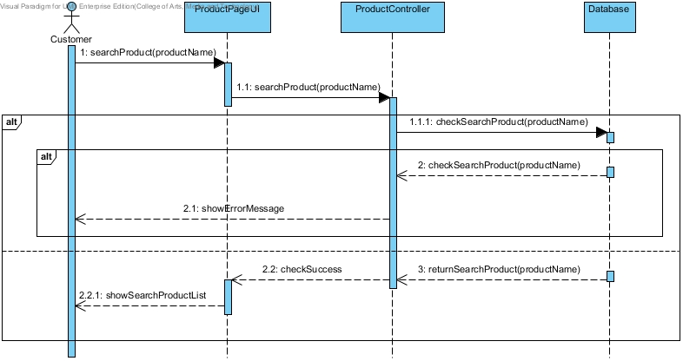

***SD-06: Search Product By Name***

**ITC-17**

Check the integration between ProductService and ProductDAO by checkSearchProduct() method

|  |  |
| --- | --- |
| **Test Case ID** | ITC-17 |
| **Test Item(s)** | ProductService → ProductDAO |
| **Test Description** | Check for product name from search parameter that user input |
| **Expect Output** | Return list of product that its name match with search parameter. |
| **Actual Output** |  |

**Input Data**

|  |  |
| --- | --- |
| **Product Name** | Genie |
| **Product Name** | Doll |
| **Product Name** | Aladdin Classic Doll |

**URS08 - The customer can add product to shopping cart.**

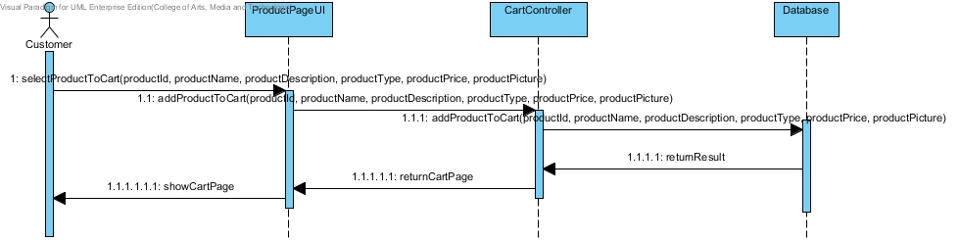

***SD-07: Add Product To Shopping Cart***

**ITC-18**

Check the integration between CartService and CartDAO by addProductToCart() method

|  |  |
| --- | --- |
| **Test Case ID** | ITC-18 |
| **Test Item(s)** | CartService → CartDAO |
| **Test Description** | Select product to add from product id, name, description, type, price, and picture that user select |
| **Expect Output** | Added product is displayed in the user shopping cart. |
| **Actual Output** |  |

**URS11** - The customer can choose option of payment (money transfer, credit card and PayPal).

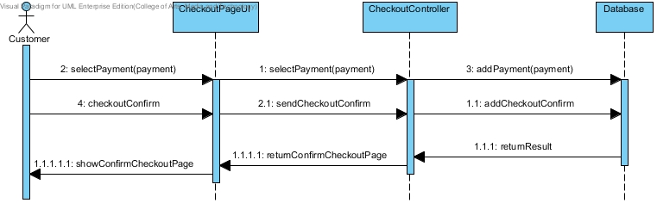

***SD-08: Select Payment Method***

**ITC-19**

Check the integration between CheckoutService and CheckoutDAO by addPayment() method

|  |  |
| --- | --- |
| **Test Case ID** | ITC-19 |
| **Test Item(s)** | CheckoutService → CheckoutDAO |
| **Test Description** | Input the payment method from payment method option that user select |
| **Expect Output** | Chosen payment method is added to the user shopping cart. |
| **Actual Output** |  |

**ITC-20**

Check the integration between CheckoutService and CheckoutDAO by addCheckoutConfirm() method

|  |  |
| --- | --- |
| **Test Case ID** | ITC-20 |
| **Test Item(s)** | CheckoutService → CheckoutDAO |
| **Test Description** | Confirm the checkout item in shopping cart that user select |
| **Expect Output** | Display the confirm checkout result. |
| **Actual Output** |  |

**USR12** - The customer can see their history buying transaction.

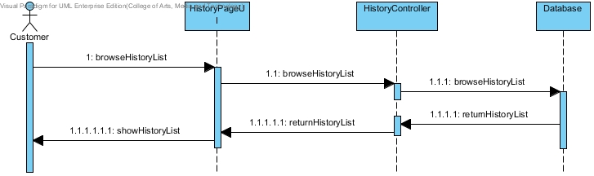

***SD-09: Check Transaction History***

**ITC-21**

Check the integration between HistoryService and HistoryDAO by browseHistoryList() method

|  |  |
| --- | --- |
| **Test Case ID** | ITC-21 |
| **Test Item(s)** | HistoryService → HistoryDAO |
| **Test Description** | Browse all the transaction histories made by user. |
| **Expect Output** | Display list of transaction histories that user has made. |
| **Actual Output** |  |

**URS13** - The administrator can see all of the history buying transaction.

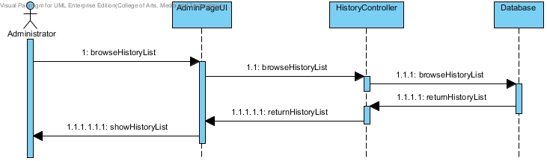

***SD-10: Check Transaction History of All Users***

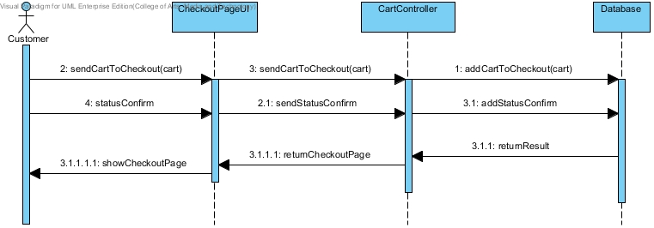

***SD-11: Save Shopping Cart***